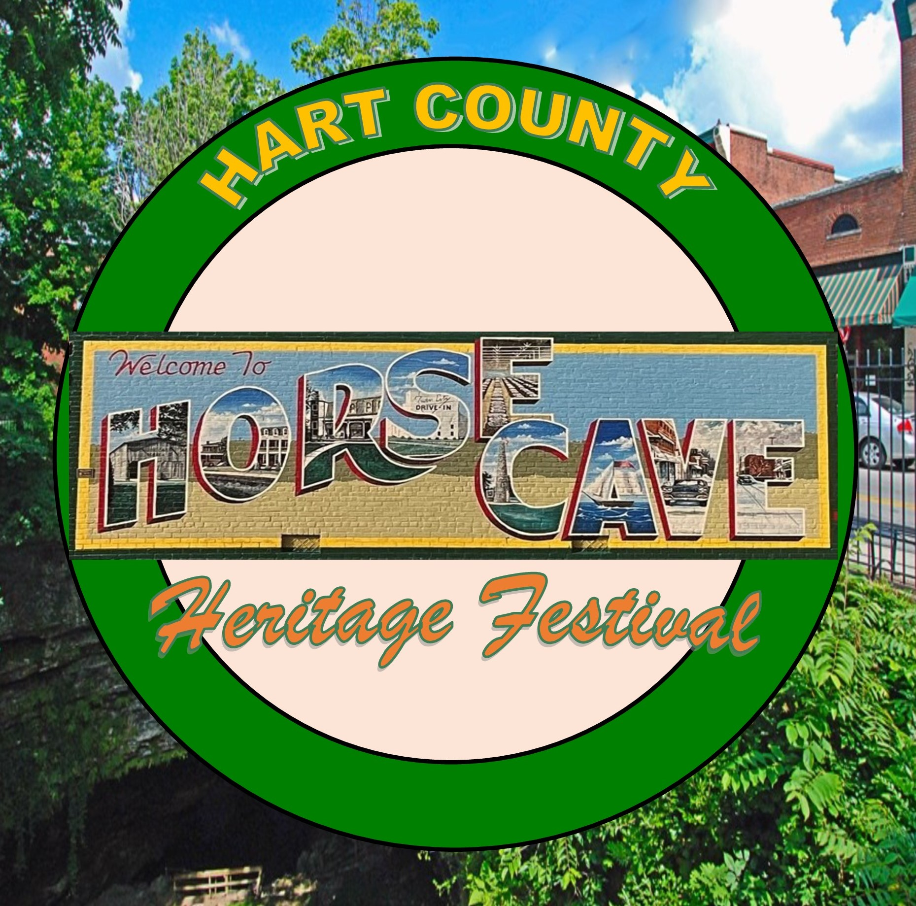
HORSE CAVE HERITAGE FESTIVAL
Downtown Horse Cave on Main St.

September 19-20, 2025
**FOOD TRUCK APPLICATION**

BUSINESS NAME:_____________________________________________________________________

CONTACT PERSON:_________________________ CELL #:____________________FAX:_________________

ADDRESS:____________________________________________________________________________

CITY, STATE, ZIP:______________________________________________________________________

E-MAIL: _____________________________________________________________________________________________

- FRIDAY EVENING & ALL-DAY SATURDAY -
SETUP TIME FRIDAY 1PM-4PM
FRIDAY OPENING CEREMONY-4:30 PM

BOOTH FEE for both Fri and Sat.
Please circle one: $150.00- (1) 10x20 space 2 spaces-$250.00

(We accept Cash, Check or Money Order only)

Size of Food Truck/Trailer:

Using the information provided as a guide, indicate your total amperage needed noting 20 AMPS per 110v circuit. (Some places may require a generator)
Total amps______ 110v Circuits required________ (bring your own heavy-duty cords)
Do you require 220v? ___ 30amp__/__ 50amp__&__ 3wire__/__ 4wire____

HEALTH DEPT INSPECTION STICKER MUST BE POSTED
We request all booths/vendors remain intact and open until 8:00 p.m. Friday (music till 9:00) and 7:00 pm Saturday (music till 9)
1) Send proof of insurance with application
2) Vendors are responsible for collecting sales tax per KRS. The Horse Cave Heritage Festival does not collect sales tax nor is responsible for submitting any taxes collected.

PLEASE DESCRIBE FOOD TYPE TO BE SOLD
____________________________________________________________________________________________________________________________________________________
_________________________________________________________

The following items cannot be sold or distributed at the festival: firecrackers, hair paint, noisemakers, smelling toys, smoking toys, squirt guns, stink bombs, stun guns and toys that project objects.
Failure to abide by this regulation will result in your dismissal from the festival.

PLEASE MAIL THIS SIGNED FORM WITH YOUR REGISTRATION FEE TO:
(Keep last page for information you might need)

Horse Cave Heritage Festival P.O.Box 326 Horse Cave, KY 42749

A space of approximately 20’ x 10’ will be allocated. Booth rental fees are listed above. There will be a maximum of two booths per exhibitor. Exhibitors must furnish their own heavy duty extension cord(s). The Horse Cave Heritage Festival reserves the right to deny admittance to any exhibitor it deems to have questionable, offensive, objectionable, or dangerous items. Acceptance is not based on your check being deposited. If you are denied admission, a refund check will be sent to you within 30 days. Refunds of booth rentals are made only if admission is denied.
Vendors are responsible for the collection and submission of sales tax to the Kentucky Revenue Dept as required by KRS.
The undersigned desires to participate in the Horse Cave Heritage Festival, which is a community celebration made up of volunteers organizing events for the betterment of the local community and the enjoyment of the attending public. The undersigned hereby acknowledges that he/she is participating in this event at his/her own risk. By signing this Waiver and Release, the undersigned is waiving, releasing and forever discharging any and all claims against the City of Horse Cave, The Horse Cave Cultural District, committee volunteers and each of the other participants in the Horse Cave Heritage Festival, whether claims are foreseeable or not at the time of the signing of this Waiver & Release. The undersigned, by signing this Waiver & Release, further acknowledges that he/she has made suitable arrangements for the protection and insuring of his/her own person and property from any occurrence causing damage to such property. This Waiver & Release extends to any and all subrogation claims by the undersigned’s insurer arising out of any claims paid in connection with any of the matters herein waived and released. This Waiver and Release includes the use of photos, video, and audio for promotional purposes that may show images of vendors and participants at the festival.

Signature: ______________________________________________

* * * * * * * * * * * * * * * * * * * * * * * * * * * * * * * * * * * * * * * * * * *

FOR YOU TO KEEP

FRIDAY EVENING & ALL DAY SATURDAY -
SETUP TIME FRIDAY 1PM-4PM
FRIDAY OPENING CEREMONY-4:30 PM

Vendor parking on city owned property located at:
*North of Main St behind Tri-County Oil *South of Main St on Cave St
*Maple Ave Park parking lot

- DO NOT PARK in People’s Bank, German American Bank, Terrazul Restaurant, Master Pawn lot, Rock of Christ Church lot—these are private lots, & Horse Cave Baptist Church lot

DUE TO SAFETY, WE CAN NOT ALLOW VEHICLES IN THE FESTIVAL
AREA OF MAIN STREET AND WATER STREET
BETWEEN 4PM FRIDAY UNTIL AFTER 7PM SATURDAY

NO: Skateboards, hover boards, razors, bicycles, and such like or motorized vehicles (wheel chairs accepted) allowed in Main St festival area.
Committee volunteers will use golf carts and Kabotas in the festival area.

PETS: ALL pets and/or service dogs MUST be on a leash. Service dogs recognized by ADA.

The Festival Committee works hard to have an enjoyable and respectable festival for everyone. We greatly appreciate your cooperation and understanding. These rules are necessary to assure a safe environment for vendors, performers, volunteers, and guests.
Thank you.

The Horse Cave Heritage Festival Committee

For more information, call 270-786-2680 (office) or 270-537-5516 (during festival)

http://www.horsecaveky.org www.facebook.com/horsecaveheritagefestival
horsecave@hotmail.com

